**Assignment number #2**

**Comparative Programming languages**

***Functional Specification***

|  |  |
| --- | --- |
| Author / Student Number | LARRY LOIC KEMMO TEJIOKEM (5049408) |
| Instructor | Stephen Johnson |
| Program | Game Development |
| Date | 03-10-2022 |

# Table of Contents

Table of Contents 2

Requirements Summary 3

System Requirements Summary 3

Use Case Diagram 7

In-Depth Use Case summary…………………………………………………………..8

Class Diagram………………………………………………………………………….12

Activity Diagram 12

Overall game design…………………………………………………………………...13

Assumptions and Dependencies 13

Feature Cuts and Unsupported Scenarios 14

References 15

# 

# Requirements Summary

The Mountain Game application will test your reflexes by producing 10 rocks at the top the screen, which will gradually fall down to the floor at different speed. The player will have to dodge the rocks as they fall for as long as possible to get a highscore. The highscore will then be stored and displayed so the player can attempt to beat it in the next party.

# System Requirements Summary

In order to develop this program, a couple of hardware and softwares are necessary.

**SOFTWARES**

**Microsoft Word**

To develop this game, Microsoft Word will be of great use for the documentation of ideas, pseudocodes, assumptions, limitations, and for the overall presentation of the program documentation. In this case, for Microsoft Word to function at maximum capacity, it will require a maximum capacity of 4GB RAM capacity computer.

**DIA**

DIA is a flowchart and UML design software that helps in the digitalized drawing of flowcharts with the use of the adequate shapes and Information. For the development of this program, DIA will need to be installed on the computer and its only specification is for the computer to be running windows operating system.

**Java**

Java is a programming language that helps in the development of applications and games. In the accomplishment of this task, Java programming language will be needed to be able to program using libgdx libraries. Java requires as far as hardware is concerned a Minimum of Windows 95 software, an IBM-compatible 486 system , a Hard Drive, Minimum of 8 MB memory, and a CD-ROM drive. On the software specification side, Java will require an Operating System, Java SDK or JRE 1.6 or higher, and Supported Database and library that supports the database connection with Java.

**Eclipse IDE**

An integrated development environment (IDE) is a **software application that provides comprehensive facilities to computer programmers for software development.** An IDE normally consists of a source code editor, build automation tools, and a debugger. For the development of this game, Eclipse will be installed on the computer as the main IDE for the Java and python versions of the game. Eclipse for optimal performances requires a Windows 10 operating system, 8GB of RAM, and a router or ethernet connection for notable improvement in performance over 100MHZ.

**Visual Studio 2022**

Visual Studio is an Integrated Development Environment (IDE) developed by Microsoft to develop GUI (Graphical User Interface), console, Web applications, web apps, mobile apps, cloud, and web services, etc. With the help of this IDE, you can create managed code as well as native code. It uses the various platforms of Microsoft software development software like Windows store, Microsoft Silverlight, and Windows API, etc. It is not a language-specific IDE as you can use this to write code in C#, C++, VB (Visual Basic), Python, JavaScript, and many more languages. It provides support for 36 different programming languages. It is available for Windows as well as for macOS. For the development of this game, Visual Studio will be installed on the computer as the main IDE for the C# version of the game

**Libgdx**

libGDX is a cross-platform Java game development framework based on OpenGL (ES) that works on Windows, Linux, macOS, Android, your browser and iOS. This library will be installed on the computer for the development of the java version of the game.

**Pygame**

Pygame is a set of [python](http://www.python.org) modules designed for writing video games. Pygame adds functionality on top of the excellent [SDL](http://www.libsdl.org) library. This allows you to create fully featured games and multimedia programs in the python language. This library will be installed on the computer for the development of the python version of the game.

**MonoGame**

**MonoGame** is an Open Source implementation of the Microsoft XNA 4 Framework. Our goal is to allow XNA developers on Xbox 360, Windows & Windows Phone to port their games to the iOS, Android, Mac OS X, Linux and Windows 8/10.As well as PlayStation Vita, Xbox One and PlayStation 4. This library will be installed on the computer for the development of the C# version of the game.

From the above software requirements, an appropriate computer capable on handling this project will be the ASUS VivoBook 15**.** Its specifications are 15.6 inches screen size,1920 x 1080 resolution, Central Processing Unit: Intel Core i5-1005G1, RAM: 8GB, 512GB storage capacity, Dimensions: 14.2” x 9.6” x 0.8”, and Windows 10 operating system. It costs $507.32 on amazon without taxes.

In total, the development of this program will cost:

|  |  |
| --- | --- |
| Assets | Price |
| Price of computer | $507.32 |
| Microsoft office monthly subscription | $11.07 per month |
| Adobe Photoshop 2022 | $27.99 per month |
| Total | $545.78 |

# 

# Use Case Diagram

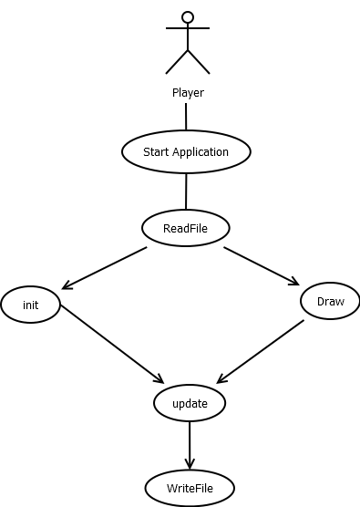

# In-Depth Use Case Summary

**Use Case 1**

**Init**

Participating actor: System

Entry Condition: Game Start

Exit Conditon: Rocks are produced

Event Flow: System produces rocks that are drawn on the screen at specific positions

**Detailed Event Flow**

Begin

* System calls read method
* System initialises font
* System initialises TextPosition, TimerPosition, EndTextPosition, ScorePosition
* System initialises background, rectangleBackground
* System initialises Player, PlayerRectangle
* System produces rocks
* System assigns rock a random X and Y position
* System adds rocks to RockArray

End

**Use Case 2**

**Update**

Participating actor: System

Entry Condition: Rocks were produced

Exit Conditon: Player losses

Event Flow: - System keeps producing rocks while player is still living

**Detailed Event Flow**

Begin

* System increases welcome textposition X by 1 every frame
* If textposition X > screenwidth

Set textposition X to 0

* Draws (Player, Rock, and background) every second
* System increments rockYPosition by 1
* If rockYPosition X > screenHeight

Set rockYPosition X to random Y position in the range -100 to -50

* System initialises Collision
* If Collision equals True

Set gameon Boolean to false

System displays gameover on the screen

* Else

If Left key is pressed and PlayerXPosition is < screenWidthheight

playerXposition increment by 1

If Right key is pressed and PlayerXPosition is > 0

playerXposition decrement by 1

End

**Use Case 3**

**Draw**

Participating actor: System

Entry Condition: Update is called

Exit Conditon: Acting sprites are drawn

Event Flow: - System calls random function and generates a key

**Detailed Event Flow**

- System draws background

- System draws welcome text

- System draws score

- System draws Player

- System draws each and every rock in the RockArray

End

# Class Diagram

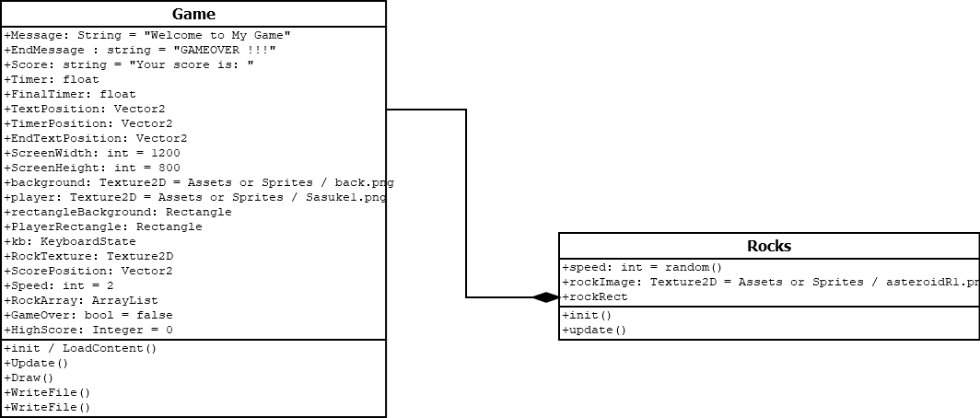

# Activity Diagram

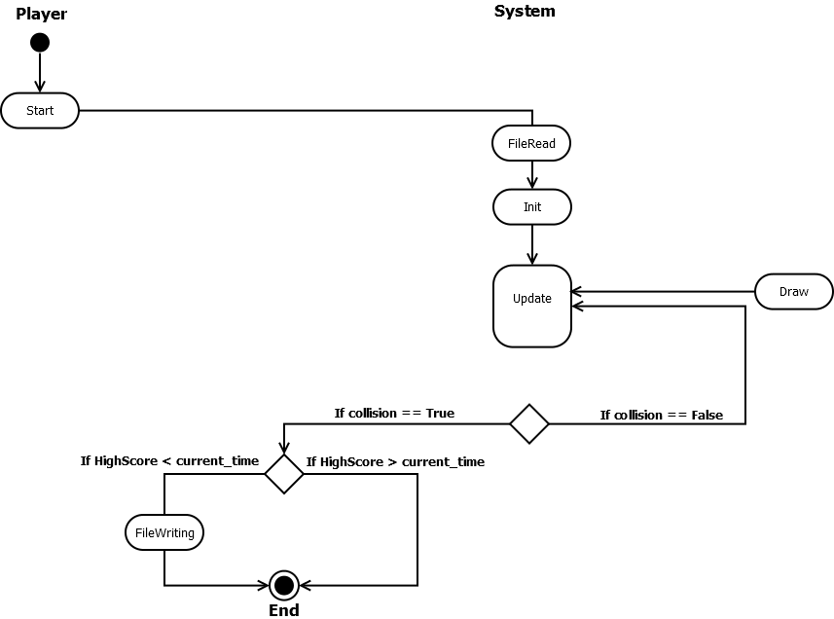

# Overall Game Design

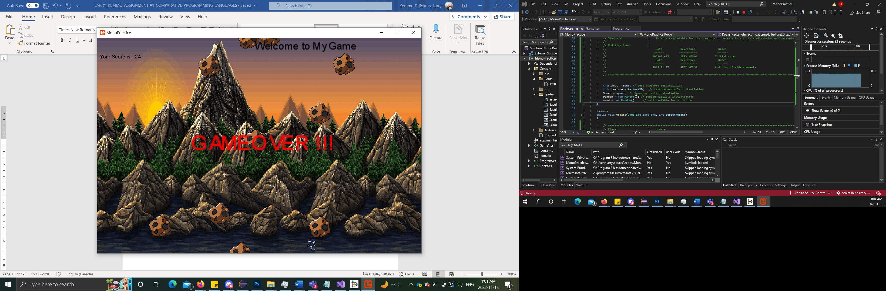

All graphics were originally designed and resized using adobe photoshop, then imported to the game project. Fonts on the other side were all taken from the options availabled by default on the 3 libraries (libGDX, pygame, monogame)

# Assumptions and Dependencies

To build this Game application, some assumptions and dependencies made were:

- Player’s score will be dependent on the amount of time he goes without being crushed by the rocks

- Rocks’ speed are randomised

- Highscore functionality is enabled.

# Feature Cuts and Unsupported Scenarios

Some future cuts and unsupported scenario associated with building of the GuessGame application are:

- Game Application doesn’t support multiplayer mode

- rocks production never increases as time goes by (Constant)

- Saving progress will not be supported.

- in an event of current score being grater than highscore, an abrupt closing of the program will not activate the highcore saving functionality

# 

# References

*libGDX*. (n.d.). libGDX.com. Retrieved November 18, 2022, from https://libgdx.com/

*About | MonoGame*. (n.d.). https://www.monogame.net/about/

*About - pygame wiki*. (n.d.). https://www.pygame.org/wiki/about

Microsoft. (n.d.). *Compare All Microsoft 365 Plans (Formerly Office 365) - Microsoft Store*. Microsoft. Retrieved January 21, 2022, from https://www.microsoft.com/en-ca/microsoft-365/buy/compare-all-microsoft-365-products-b

Busbee, K. L. (2018, December 15). *Integrated Development Environment – Programming Fundamentals*. Pressbooks. Retrieved January 21, 2022, from https://press.rebus.community/programmingfundamentals/chapter/integrated-development-environment/#:%7E:text=An%20integrated%20development%20environment%20%28IDE%29%20is%20a%20software,Some%20IDEs%20contain%20a%20compiler%2C%20interpreter%2C%20or%20both.

*Hardware and Software requirements for Java*. (n.d.). Roseindia. Retrieved January 21, 2022, from https://www.roseindia.net/java/beginners/hardware-software-requirements-for-java.shtml#:%7E:text=%20Minimum%20hardware%20requirement%20to%20download%20Java%20on,keyboard%20and%20sound%20card%2C%20if%20required%20More%20

*Amazon.ca Laptops: ASUS VivoBook 15 Thin and Light Laptop, 15.6” FHD, Intel i5-1035G1 CPU, 8GB RAM, 512GB SSD, Backlit KB, Fingerprint, Windows 10 Home in S mode, F512JA-AS34, Slate Gray*. (n.d.). Amazon. Retrieved January 21, 2022, from https://www.amazon.ca/dp/B086QZSLDH?th=1&ref_=as_li_ss_tl&language=en_US&linkCode=gs2&linkId=de4e063865a4de273eb2ca882bb37ba5&tag=expertratin02-20

Moore, D. (2021, November 24). *Best Laptop For Word Processing*. Expert Ratings. Retrieved January 21, 2022, from https://expertratings.net/best-laptop-for-word-processing/#:%7E:text=%20Let%E2%80%99s%20now%20look%20at%20a%20few%20factors,safely%20in%20the%20laptop%20without%20the. . .%20More%20

CNET. (n.d.). *Dia download and specifications*. Download.Com. Retrieved January 21, 2022, from https://download.cnet.com/Dia/3000-2075_4-10833704.html

*Hardware Requirements Eclipse*. (2022, January 3). ECLIPSE®. Retrieved January 21, 2022, from http://eclipsepracticemanagementsoftware.com/knowledge-base/hardware-requirements/

Wren, J. (n.d.). *WindowBuilder | The Eclipse Foundation*. Eclipse Foundation. Retrieved March 17, 2022, from <https://www.eclipse.org/windowbuilder/>

GmbH, V. V. L.-. (n.d.). *Eclipse WindowBuilder - Creating user interfaces - Tutorial*. Vogel/a. Retrieved March 17, 2022, from https://www.vogella.com/tutorials/EclipseWindowBuilder/article.html#:%7E:text=SWT%20Designer%20is%20a%20visual%20editor%20used%20to,user%20interface.%20SWT%20Designer%20synchronizes%20between%20both%20representations.

Minh, N. H., & Minh, N. H. (n.d.). *JFrame basic tutorial and examples*. CodeJava. Retrieved March 17, 2022, from https://www.codejava.net/java-se/swing/jframe-basic-tutorial-and-examples#:%7E:text=JFrame%20is%20a%20Swing%E2%80%99s%20top-level%20container%20that%20renders,Almost%20every%20Swing%20application%20starts%20with%20JFrame%20window.

### 